Software Design Document
For
Extendable Desktop Search

Prepared by

K.Vineel Kumar Reddy N.Nischala
S.Rajendhran Bharat Nikitha
Rahul Kumar

Table of Contents

1. Introduction 3
1.1 Purpose 3
1.2 Project Scope 3
1.3 References 3

2. Data Design 4
2.1 Internal software data structure 4
2.2 Logical view of Indexes 4

3. Architectural Design 6
3.1 Architecture diagram 6
3.2 File System Monitor 6
3.2.1 Component Description…………………………...……………………………………………………………………..6
3.2.2 Interfaces………………………………………………………………………………………………………………………..7
3.2.3 Detailed Design……………………………………………………………………………………………………………….8
3.3 File System Crawler 9
3.3.1 Component Description..…………………………………………………………………………………………………9
3.3.2 Interfaces………………………………………………………………………………………………………………………..9
3.3.3 Detailed Design……………………………………………………………………………………………………………….9
3.4 Indexer 11
3.4.1 Component Description.…….………………………………………………………………………………………….11
3.4.2 Interfaces………………………………………………………………………………………………………………………11
3.4.3 Detailed Design……………………………………………………………………………………………………………..11
3.5 Query Engine 13
3.5.1 Component Description.……….……………………………………………………………………………………….13
3.5.2 Interfaces………………………………………………………………………………………………………………………14
3.5.3 Detailed Design……………………..………………………………………………………………………………………14

4. User Interface Design 15
4.1 Documents 16
4.2 Pictures 17
4.3 Audio and Video 18
4.4 Emails 19
4.5 Interface design rules 19

5. Other Issues 20
5.1 Performance bounds 20
5.2 Identification of critical components 20

Introduction

Purpose

Nowadays with the increase in the size of hard disc, locating a file or useful information in the system has become a tedious task, making traditional searching process a futile exercise. To address this problem we are going for desktop search. The core of any desktop search engine is the process of Indexing. Using desktop search the results (hits) are obtained almost instantaneously.

Project Scope
From the user perspective desktop search have the following advantages over other searching tools

- Case sensitive content search
- Querying files based on their metadata attributes(not possible in windows search)
- Able to search with in zip files(not present in windows search)
- Able to query remote systems provided in LAN
- Indexing makes retrieving results almost instantaneously(windows employs traditional file system scanning mechanism, which is painful if the hard disc contain relatively large number of files)
- User has the choice to change the ranking settings of an indexed document.

References
- Identifying Keywords in Metadata and Full-Text Search: http://www.kbs.uni-hannover.de/Arbeiten/Publikationen/2005/ISWC.pdf
- Semantically Enhanced Searching and Ranking: http://www.kbs.uni-hannover.de/Arbeiten/Publikationen/2005/desktop_ranking.pdf
- Inverted Index Construction: http://remote.science.uva.nl/~christof/courses/ir/transparencies/clean-w-05.pdf
- Google Desktop SDK Reference: http://desktop.google.com/dev/gadgetapi.html
- Apache Lucene Text Indexing Reference: http://lucene.apache.org/java/docs/

Data Design

Internal software data structure
Internally the indexes are organized as segments. Using segments lets us quickly add new Documents to newly created index segments and only periodically merging them with other existing segments.
This process makes additions more efficient because it minimizes physical index modifications, and helps in incremental indexing.

It internally organizes the data using a technique called inverted indexes. This data structure
makes efficient use of disk space while allowing quick keyword lookups. What makes this structure inverted is that it uses tokens extracted from input documents as lookup keys instead of treating documents as the central entities. In other words, instead of trying to answer the question “what words are contained in this document?” this structure is optimized for providing quick answers to
“which documents contain word X?”
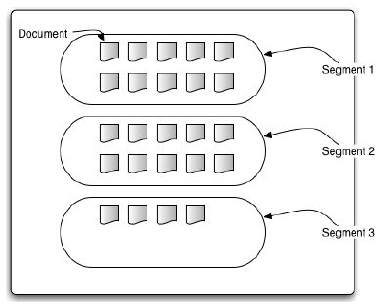

The above figure contains unoptimized index with 3 segments, holding 24 documents

Logical view of Indexes
The previous section gave an overview of how internally the indexes are organized. This section provides a logical view on how these indexes are perceived by the programmer.
Indexes can be considered a black box represented by the abstract Directory class. When indexing, we create instances of the Document class and populate it with Fields that consists of name and value pairs. Such a Document is then indexed by passing it to IndexWriter.addDocument(Document). When searching, you again use the abstract Directory class to represent the index. You pass that Directory to the IndexSearcher class and then find Documents that match a given query by passing search terms encapsulated in the Query object to one of IndexSearcher’s search methods. The results are matching
Documents represented by the Hits object.

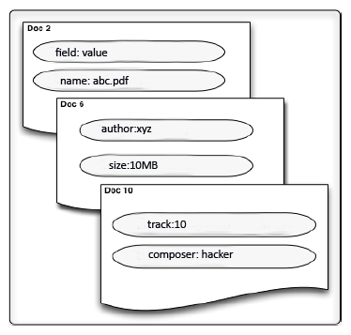

The above figure contains 3 documents with the mentioned fields and their values. We can manipulate these indexes only in terms of documents i.e., we can only add new documents or delete existing documents. This object oriented view of indexes makes it easy to organize and consume for other components in the application. The indexes also contain one important feature responsible for giving rank to each document, it is called boosting factor. By default every document is indexed with a boosting factor of .5(neither important doc nor unimportant doc), by setting the boosting factor of a document below .5 implies the document is less important than usual and setting it to above .5 implies the document is more important. This attribute to every document is very helpful in sorting the results in the order of their importance. The boosting factor varies from 0 to 1 with the default being .5

Architectural Design
This section gives an overview of internal design of Extendable Desktop Search.

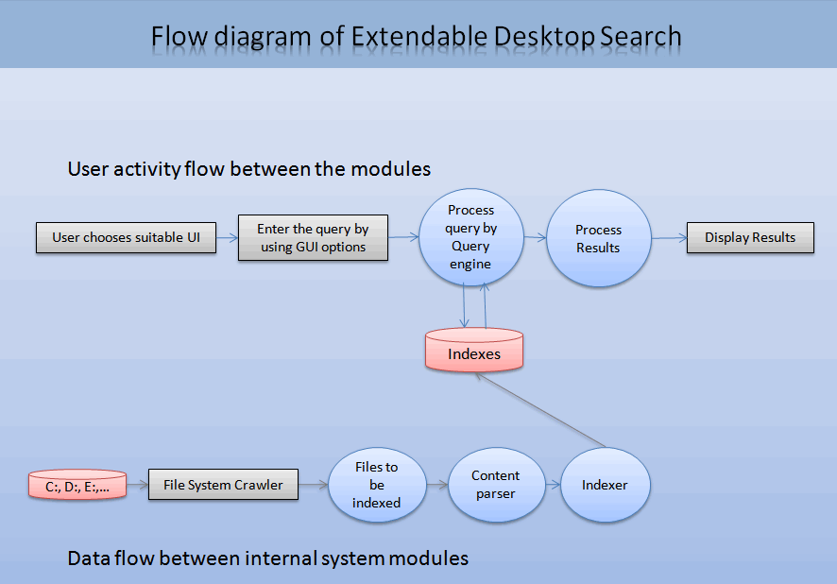

The following is the indexing architecture of the application.
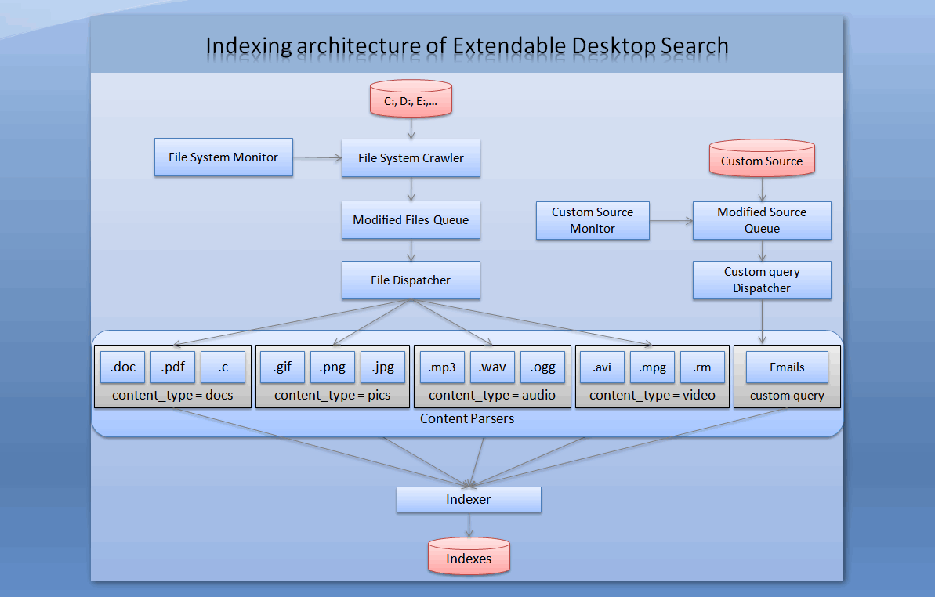

The following is the query engine architecture of the application.

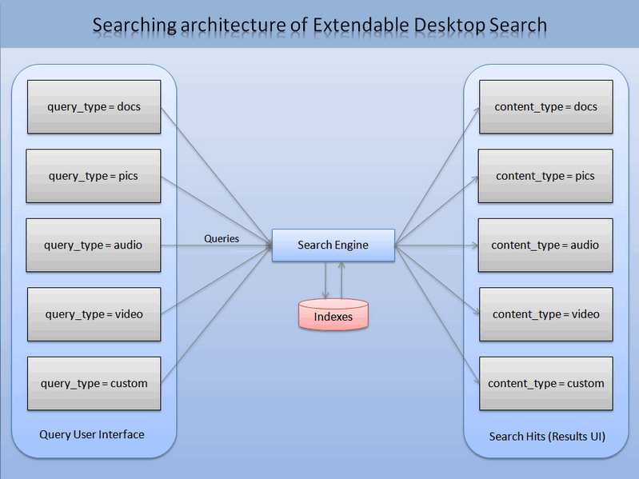

The following sections give an in depth details about the components present in the above diagram.

File System Monitor
3.1.1 Component Description
The responsibility of this module is to look after the file system changes that have occurred due to creation, deletion, updation of files by the user. It then analyses the changes and triggers File System Crawler to update the indexes. It will also monitor the open files that are being used by the currently running processes in the system, as these files are more likely to be modified (a file opened in notepad has more chance of getting modified than the files not opened by any process).

3.1.2 Interfaces
The file system monitor interfaces with File System Crawler component and Modified File Queue data structure.
The following tasks are performed by File System Monitor
- Monitor the file system activities and captures file delete, create, change and rename events.
- Checks whether we have sufficient permissions to read the event generated source (deleted, updated file) or not.
- Then this module encapsulates the event details in to FileOperation class.
- Finally the path to the event and FileOperation object will be stored in a Dictionary data structure.

3.1.3 Detailed Design
The following figure shows the attributes and operations performed by various classes under File System Monitor component.

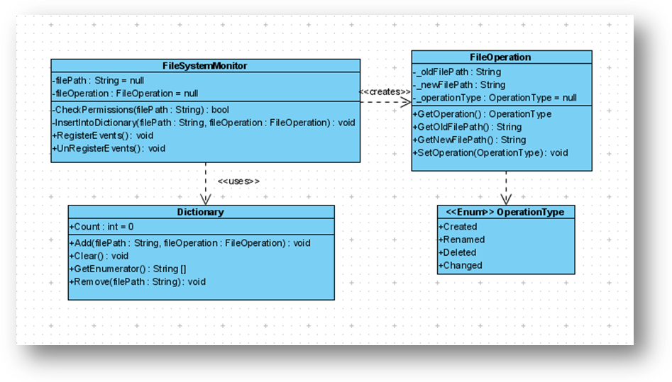

The classes that interface with File System Monitor in its operations are

- FileOperation : Encapsulate a file system event. It holds the details
pertaining to the event i.e., file creation, deletion,
renaming, modification.

- OperationType: It’s an enumeration type holding four constants namely
created, deleted, renamed, changed
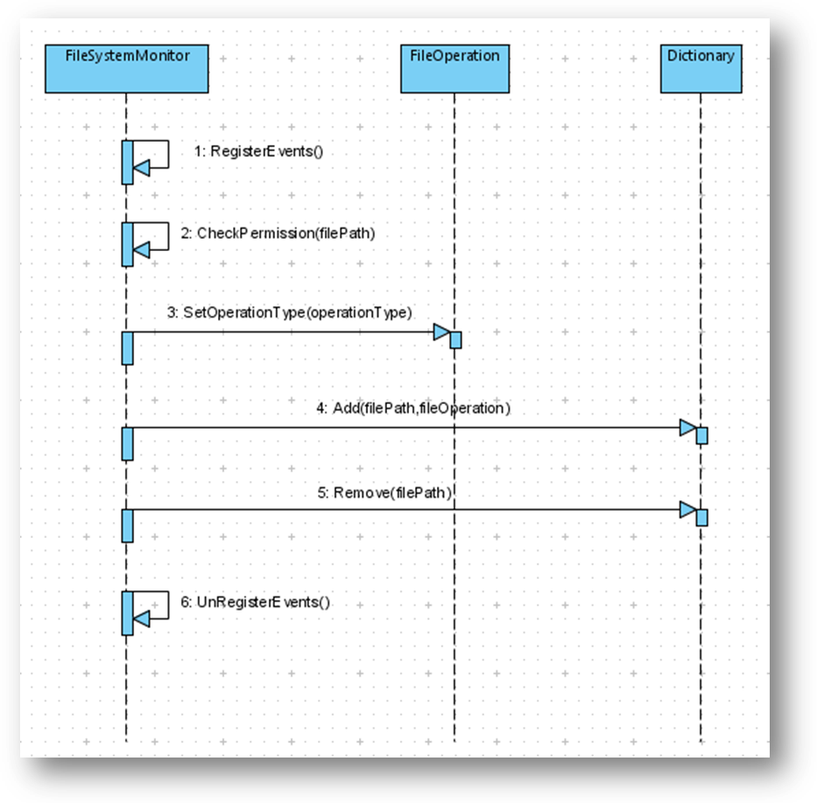
- Dictionary: This data structure is responsible for storing the
occurred event, which are later retrieved by File System
Crawler component. This class has an Add operation
which is used to insert a key,value pair, key being
the path to the occurred file event and value being
the file operation object pertaining to the event.

The above sequence diagram shows the interactions between different objects that are responsible for file system monitor operations.

File System Crawler
3.2.1 Component Description
It will scan the hard disc at regular intervals to collect the files that need to be indexed and maintains them in a queue. This module is designed to calculate the CPU’s idle time to schedule itself for the next scan. In this way the user at work will not be interrupted by the crawling activity.

3.2.2 Interfaces
This component interfaces with File Dispatcher, Indexer components for its
functionality.

The following tasks are performed by File System Crawler
- Periodically checks whether the system is idle or not.
Using various performance counters
- Determine the type of event generated by analyzing the OperationType object and takes the necessary action.
- For deletion event this module opens the index and deletes file content from the index.
- For other type of actions this module invokes the File Dispatcher class, responsible for determining the file type and calls the appropriate content handler to parse the contents of the file in to key, value pairs.
- Now these key, value pairs list is passed to Indexer.

3.2.3 Detailed Design
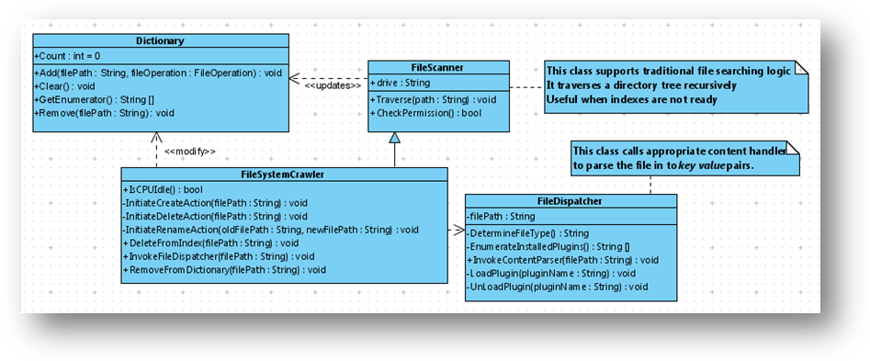
The following class diagram shows the attributes and operations performed by
various classes under File System Crawler component.

The classes that interface with File System Crawler for its operation are

- FileDispatcher : It is responsible for invoking the appropriate content
parser to parser the given file in to key, value pairs list.
It also contains the list of installed plug-ins.

- FileScanner: It is the super class of FileSystemCrawler. It’s sole
purpose is to provide traditional searching feature in
situations where the indexes are not ready.

- Dictionary: This class has an Add operation which is used to insert a
key,value pair, the key being the path to the occurred
file event and the value being the file operation object
pertaining to the event. It also supports Remove
operation for deleting the entries once they are
indexed

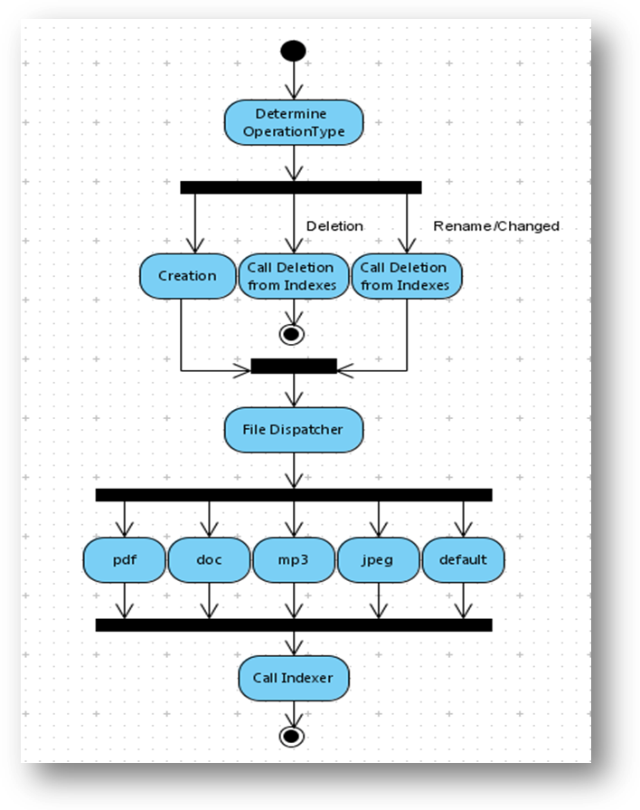

The above activity diagram shows the flow of activity from file system crawler to indexer component.

Indexer
3.3.1 Component Description
This is the core component responsible for indexing the contents of major document formats (.doc, .pdf), metadata attributes of audio and other binary file formats.

Indexing module will intelligently assign a ranking factor to the file being indexed, based on the number of times the file got updated/read.

The indexing module can only understand the data in textual format, as a result, extraction of textual information from documents and other binary files will be handled by Content Parsers module.

The textual information given to indexing modules will be in KEY, VALUE pair. For example if ‘content’ is the key then the document’s content is the value, if ‘author’ is the key then the file author name is the value.

The indexing module filters the unnecessary linguistic words (an, the, in etc) from being indexed, greatly reducing the size of indexes. This module uses Inverted Indexing scheme to organize the data.

3.3.2 Interfaces
At the heart of this component are two classes namely IndexWriter and IndexReader. They encapsulate the inner working of the indexer by providing useful operations (methods).

The tasks performed by indexing module are as follows

- Indexer is initialized by creating an IndexWriter object with directory path to store the created indexes.
- We create a Document object which contains the Key, Value pair details.
- This document object is added to IndexWriter object created above.
- Finally the IndexWriter object is closed to save the indexes to disc.

3.3.3 Detailed Design
The following class diagram shows the attributes and operations performed by the
above mentioned classes in indexing component.

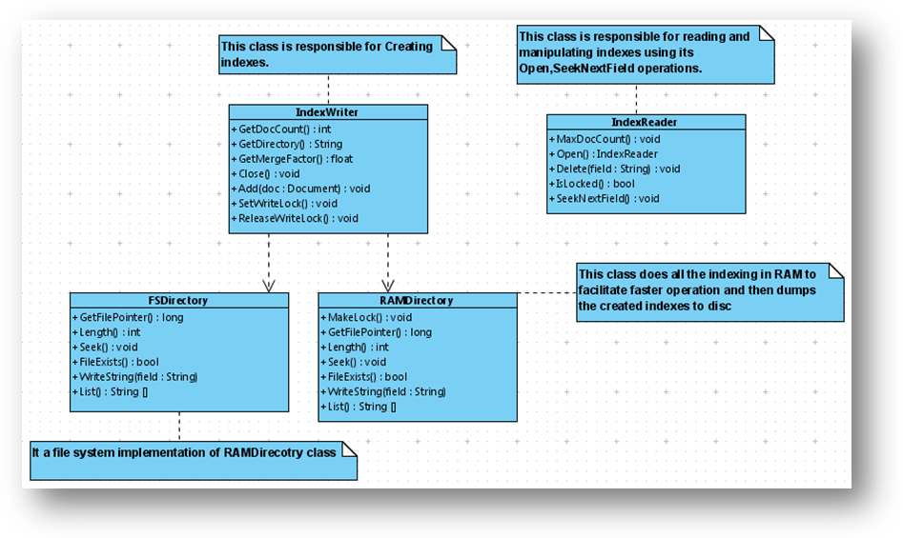
The indexer component is again divided into various subcomponents to alleviate the complexity.
- FSDirectory: This class manages a directory that contains the
indexes. It provides better tradeoff between
memory space and indexing time.
- RAMDirectory: This class does all the indexing in RAM to facilitate
faster operation and then dumps the created indexes
to disc.
- IndexWriter: This class holds a set of documents that need to
indexed. It provides various sophisticated operations
like setting boost factor on the document to be
indexed etc.
- IndexReader: It does exactly the opposite of IndexWriter. It can be
used to reader the indexes or modify them.

The following figure gives sequence of operations performed by various active objects that make up indexing component.
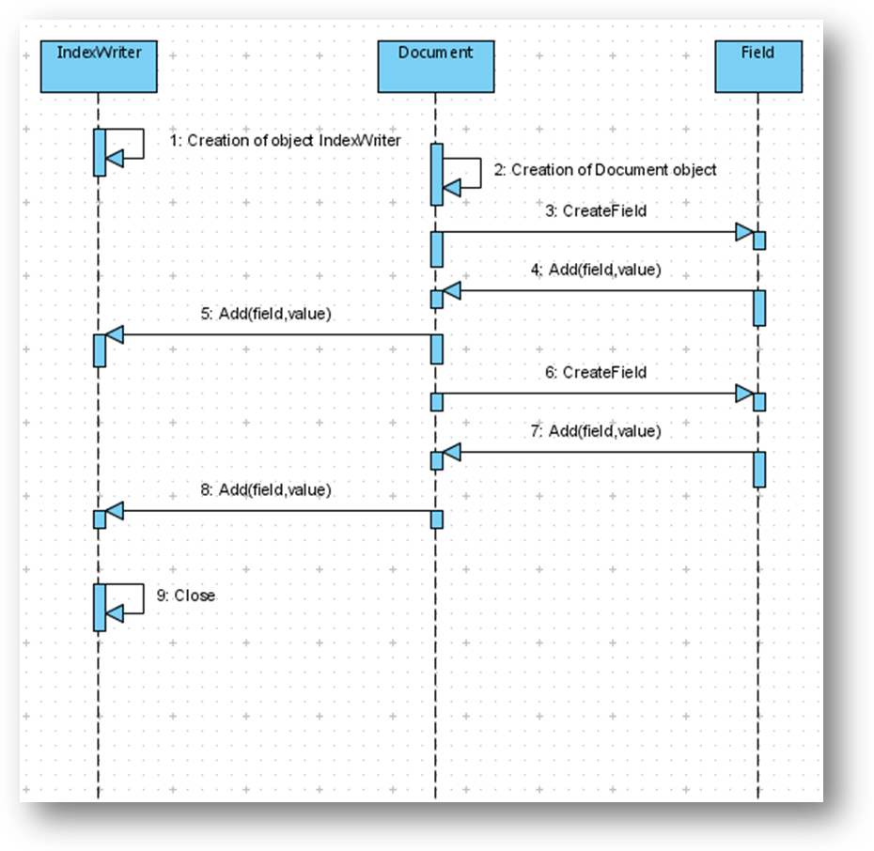

Querying Engine
3.3.1 Component Description
This component is responsible for Information Retrieval part of the application.
User mainly interacts with this component with a well design GUI controls.
The responsibility of query engine is to constructing the query from user selected options and fetch the results from the indexes and display back them to the user.

Information Retrieval is considered crucial from the perspective of end user in terms of getting not only accurate results but also arranged in a semantically correct order.

3.3.2 Interfaces
The classes pertaining to the operation of query engine are Directory, IndexSearcher and Query.

The tasks performed by query engine module are as follows

- Construct the query from user selected options, it also handles invalid inputs given by the user and tries to anticipate the relevant query.
- Passing the query to indexer to retrieve the result from the previously created indexes.
- The obtained results are analyzed for their semantic information and order according to their boost factor.
- Returns the final result set to the UI used to display the results.

3.3.3 Detailed Design
The following class diagram shows the attributes and operations
performed query engine component.

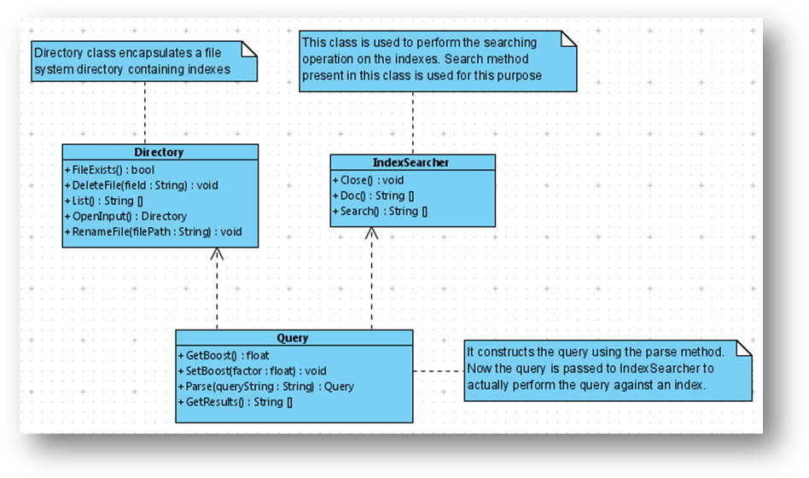

The following use case demonstrates the behavior a user (actor) and the query engine module.

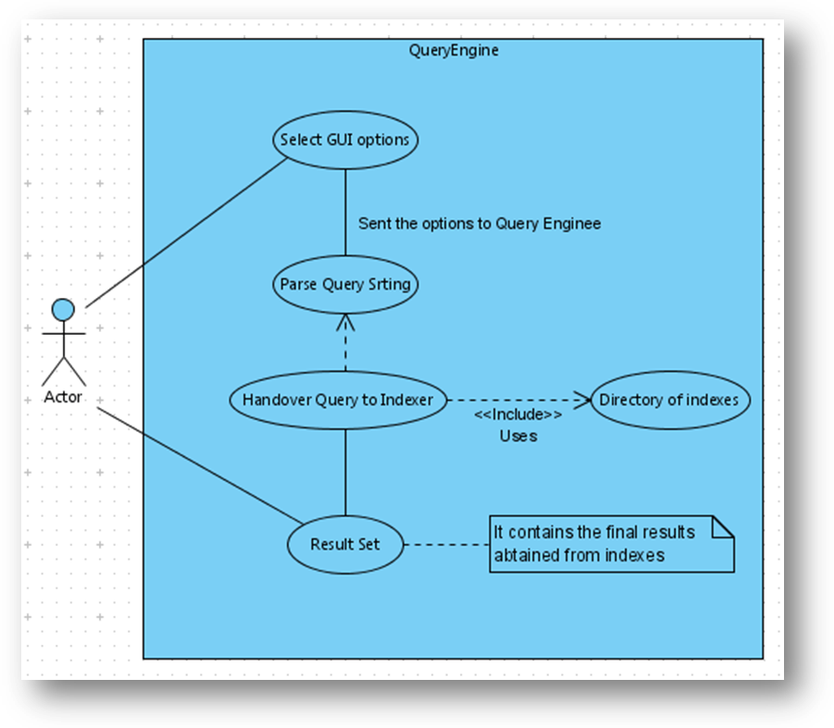

User Interfaces
Extendable desktop search provides user interface for following content types

- Documents
- Pictures
- Audio
- Video
- Email

4.1 Documents

This interface provides the user for searching files based on following properties

- File Name
- Size
- Type
- Date
- Content
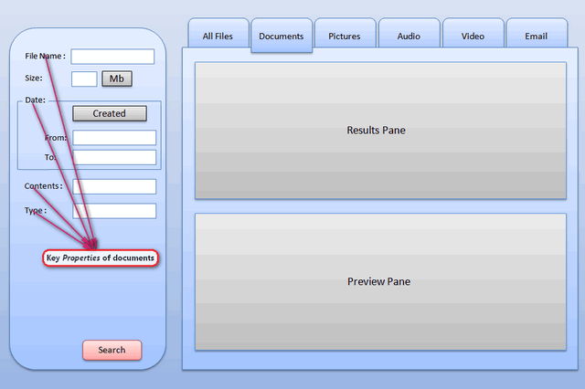

User has the choice of entering any of the details for the above properties. The important property of this interface is the Contents property, this field is responsible for querying the documents based on their contents.
The application is built with following popular content handler specific to documents.

- Microsoft Word
- Adobe Portable Document Format
- Web Documents (Html, Htm )
- Compressed Files(rar,zip,gzip,bz2)

Other unknown document formats cannot be queried based on their content property. Document formats that have no valid content handler will can only be queried on their basic properties like File Name, Date, Size etc

4.2 Pictures

This interface provides the user for searching image files based on following properties

- File Name
- Size
- Date
- Type
- Dimension
- Color Depth
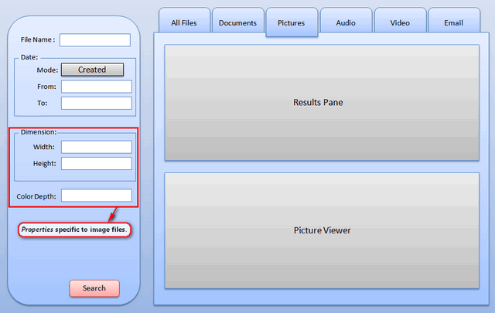

Coming to pictures all the basic properties (File name, Size, Date) remains same. The Extra properties that are specific to pictures are Dimension, Color Depth. Dimension field is responsible for querying the documents based on their Dimension (Height, Width).
Color Depth field is responsible for querying the documents based on their Color Depth Values (1, 8, 16, 24, 32, 48, 64).
The application can handle following image formats.

- Bitmap (bmp)
- Graphics Interchange Format(gif)
- Joint Photographic Experts Group Format(jpeg)
- Portable Network Graphics (png)
- Tag Image File Format (tiff)
- Exchangeable Image File(exif)

Other proprietary image formats like photoshop document (psd) can only be handled if the appropriate handler is present.

4.3 Audio and Video

This interface provides the user for searching audio files base on following properties

- File Name
- Size
- Date
- Duration
- Title
- Artist
- Album
- Genre

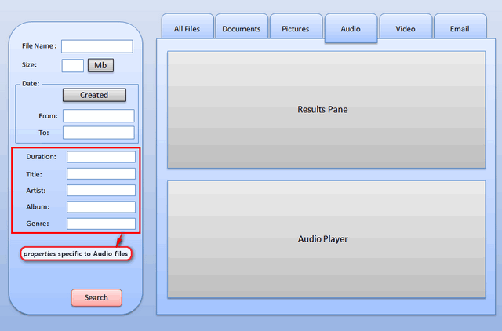

This interface gives the user full control in searching audio and video files based on various metadata properties.

The application can handle following audio and video formats.

- MPEG Layer-3 (mp3)
- Waveform audio (wav)
- Ogg Vorbis (ogg)
- Windows Media Audio (wma)
- Audio Video Interleave (avi)
- MPEG-4 (mp4)
- Windows Media Video (wmv)

4.4 Emails

This interface provides the user for searching audio files base on following properties

- From
- To
- Subject
- Body
- Date
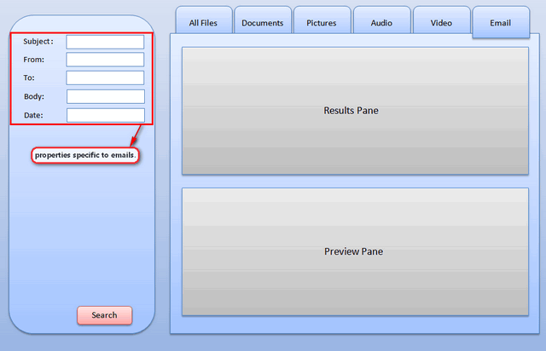

This tab page provides the user for searching emails using above mentioned properties.

4.5 User Interface Guidelines

We have chosen Winforms as our GUI framework of .NET 2.0, having consistence rich interface controls.

The following controls will be used in the project for the development of the application.

- System.Windows.Forms.Form
- System.Windows.Forms.Button
- System.Windows.Forms.TabControl
- System.Windows.Forms.Checkbox
- System.Windows.Forms.RadioButton
- System.Windows.Drawing.Color
- System.Windows.Drawing.Graphics

This software will be developed with usability in mind. It provides familiar keyboard shortcuts, uses standard GUI controls. It references the windows GUI standards from GUI Bloppers 2.0 book

The following GUI principles are taken as guidelines in designing the user interface of the software.

- Focus on the users and their tasks
- Function first, presentation later
- Don’t distract users from their goals
- Not to use any technobabble

- Other Issues

Performance Bounds

The performance bottleneck of the application is caused by indexing, file system crawler modules. At most care will be taken to optimize the routines constituting these modules by carefully estimating and utilizing the available system resources.

To estimate the available system resources, we will be using various system Performance Counters like

- Processor % Idle Time, which gives the effective number of processor cycles that are free to be utilized by the applications.

- Time elapsed between the user’s interactions(keyboard, mouse) with the system( using a routine GetLastInputInfo() )

- Average disk bytes Read/Written per sec gives a measure to know whether the hard disc is idle or busy flushing its buffers.

- Average page faults counter gives an account for the usage of RAM by the indexing module.

  - Critical components

The critical components identified for testing interms of performance of the application are Indexer, File System Crawler.
We make use of NUnit open source testing framework to rigorously perform unit testing on these components. The file system crawler component is considered critical because of its impact on resource usage of end user machine.

